AEF

- different folders issue
Different folders with same name files causes errors, more often with "Always Ask Password" option
Fixed

- run single task issue
When start (logon, restart), YGFSMon task runs multiple (we see 3 tasks) and decryption fails
Fixed

- context menu issue
Context menu decrypt files inside of AEF causes error but they are decrypted
Fixed

- modification not saved
2015/8/7 Sorry, I got this today. Sometimes the saved modifications made on files in AEF were not applied to the files, I am asking the customer now
Fixed

FileEncrypt

- context menu issue
Context menu sometimes does not appear

Haven’t recreated this issue. Need more information about this.

- Encryption self-extracting archive file feature
- Self-extracting archive file
Done.

- Convert tool
Done. The tool file name is “SelfEntractionConvertingTool.exe”. Need to work with “sefb.dll”.

- “only extract current folder only“ function
Not finished. We need you to confirm that whether to add a tick box in following UI. If user tick this option, it will decrypt the first layer only.
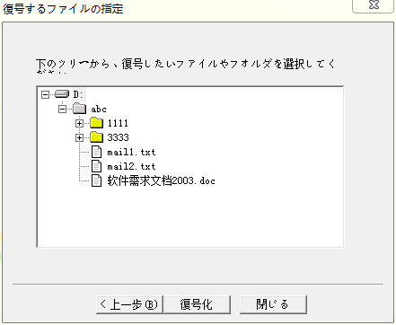
指定フォルダーのみ復号
Please add like above red rectangles.
OK, 我马上对应.
20151021 对应完毕
- issue：I run again "self-extracting", and it seems it can activate "expiration date" only in Option dialog when encrypting.
Is this correct behavior? and if so, then why other options, extract time and wrong password limitation are not removed?
Removed.

Other

- compatible with older version
Done.

- The install scrip has been changed to Unicode.

- compatible with Win10
Done.

- compatible with WinXP
Please confirm whether to be compatible with Windows XP. If it’s not needed, we can use win10 SDK for better performance.
Curently we cannot remove WindowXP support. But I have a question. Do you mean you can build another Win10SDK version without any delay?
(I do not request this, just ask)
我可以用wind10sdk编译,但是我很怀疑win10sdk编译出来的程序不会支持xp.之前支持xp的程序,就是用特殊的sdk编译出来的. 这个等我调查清楚再说吧. 既然他们说不能不支持xp, 那最差的情况就是我编译两个版本, 支持xp, win7的一个版本, 支持win7, win8, win10的另外一个版本.

20151021 Working on

- Working with cloud storage sync folders?
Done.
Work fine with
iCould
SVN
OneDrive
How about Dropbox and BitCasa? And what is the best way to use with these cloud storage (auto sync) folders and AEF?
When I try to set subfolder in OneDrive as AEF, then it says it is not possible to set AFE because it is Windows Special folder...
我没有用过dropbox和bitcasa, 等我测试再回复

20151021 Working on

- Please provide following translation in Japanese.
I add Japanese in each following line
- Convert
変換
- SelfExtractionConvertingTool
自己解凍型変換ツール
- Convertion is in progress, please wait...
変換中です、少しお待ちください...
- Convertion finished.
変換成功。
- Convertion failed.
変換失敗。
- Please select an encryption file to convert
変換したい暗号化ファイルを選択してください
- Create self-extracting file
自己解凍型ファイルを作成

20151021 对应完毕

Issues：

I am now realizing issue at "select target location" of all decrypt programs
(ie, Decrypt program and Self-extracting file) show 4 options;
Original
Relative
Current
New

Original specification was
Original: decrypt in original place, so that encrypted files include original full paths.
Relative: relative location to original.
Current: current location which the encrypted file exists.
New: newly user selected location

but Now I am checking and Releative and Current do not look like working. I grabbed test files from OneDrive to local desktop subfolder and encrypted the file inside of the subfolder. And drag that on desktop and try to decrypt. Then when select Releative or Current, nothing made.

If it is possible to remove Releative and Current and New as default selection, please do so. Or please explain how Releative and Current work now.

1.我没有测试过OneDrive, 我会去测试OneDrive.
2.我之前用普通文件和文件夹仔细测试过所有四个选项, 包括Releative and Current, 都是可以正常工作的, 而且Releative and Current两个选项有区别, 具体如何, 我回去截图给他们解释.
3. If it is possible to remove Releative and Current and New as default selection, please do so. 这句话什么意思? 他们是想说remove Releative and Current, 然后将New设置为default selection吧. 可以这么做

20151021 示例：
原始目录结构
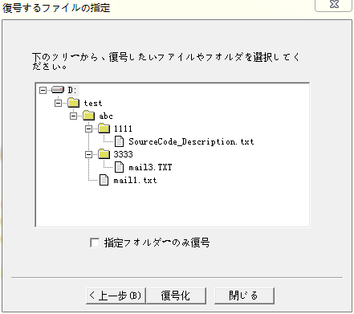

选择加密的目录是D:\test\abc， 不是D:\test
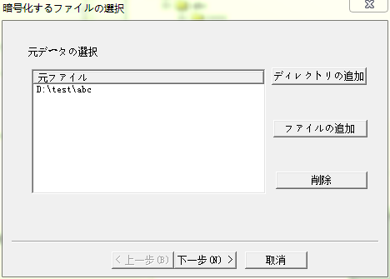

测试1
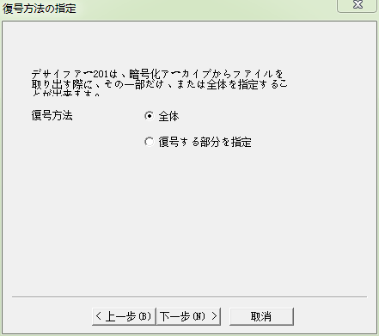

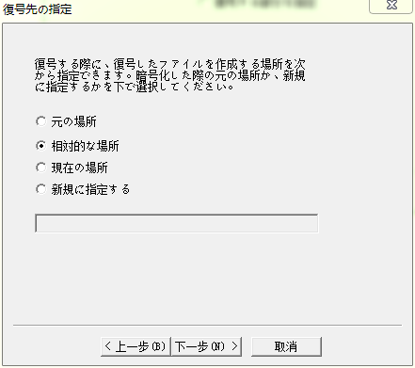
解密结果
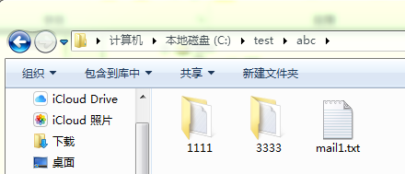

然后选择
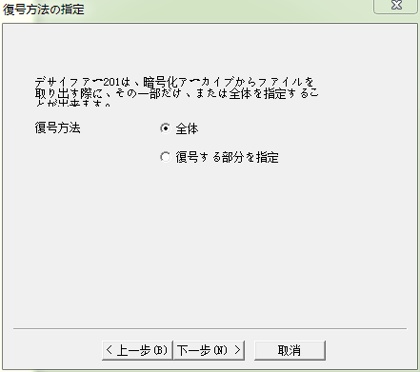
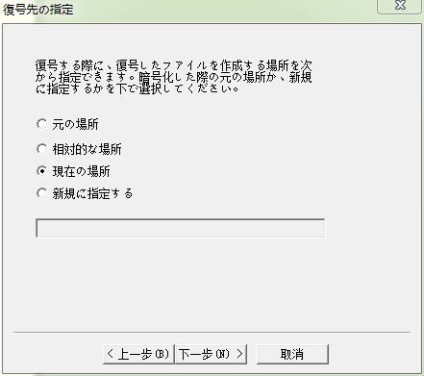
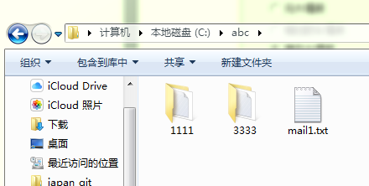
两者的区别是， relative path模式会将加密的目录的父目录的路径（test目录）恢复，而current place则不会。

测试2， 选择部分解密
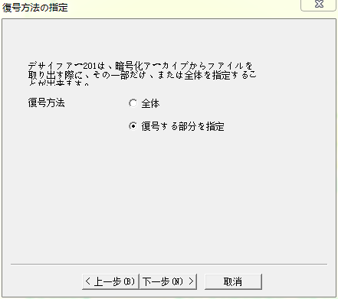

两者唯一的区别在于， 当选择current place的时候， 假如选择的解密目录是根目录
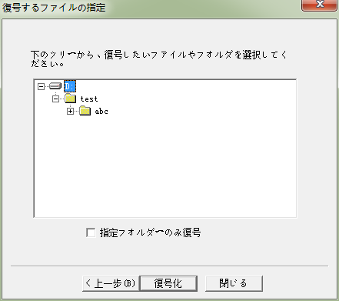
生成的文件路径会多一个“DiskD”
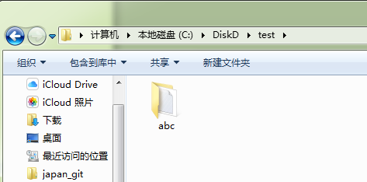

当选择relative path时， 生成的目录中没有“DiskD”
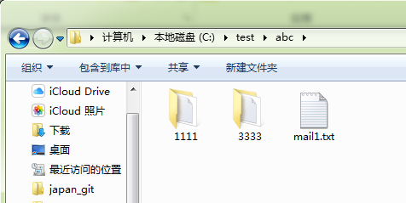
除此之外， 没有区别。

以上就是测试结果。我觉得整体解密的路径生成代码是OK的。部分解密时， current path和relative path的路径生成代码有bug。但是因为没有注释，不知道原本是像做成么样。 而且代码很久远了，用户早就习惯了，我改好了，反而和用户的预期不一致。
问日本人想么样搞吧， 原样不动， 还是删除 current path和relative path选项， 将new path作为默认选项。我不想再做其他修改。

